**Adding a Compass Draw**

To review the basics of tournament creation, please refer to the Video Explanations also on the [Tournament Planner support site](http://www.tpacanada.com/Tournament_planner_support).

1. To add a compass draw to your tournament, click on Draw at the top of the program and then Add Draw. Select Compass Draw from the list of options available.

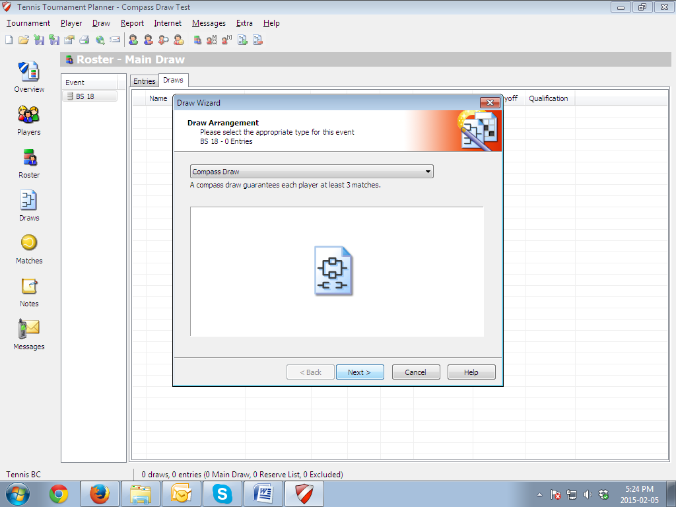

1. Following this format, all players are guaranteed a minimum of three matches
   1. Enter all player names in the ‘A Draw’ (top right) to begin the tournament. (Try to keep seeded players separate.)
   2. First round winners move to the right side of the ‘A Draw,’ while losers move to the ‘C Draw.’(Top left)
   3. The losers of the quarter-final of the ‘A Draw’ are placed into the ‘B Draw.’(Bottom right).
   4. The losers of the quarter-finals of the ‘C draw’ move to the ‘D Draw.’(Bottom left).
   5. The winner of the ‘A Draw’ is the tournament champion.