**How to Set Up a Tournament with Multiple Flights**

To review the basics of tournament creation, please refer to the Video Explanations also on the [Tournament Planner support site](http://www.tpacanada.com/Tournament_planner_support).

1. To create a tournament with multiple flights, simply create elimination draws for as many flights as you need.

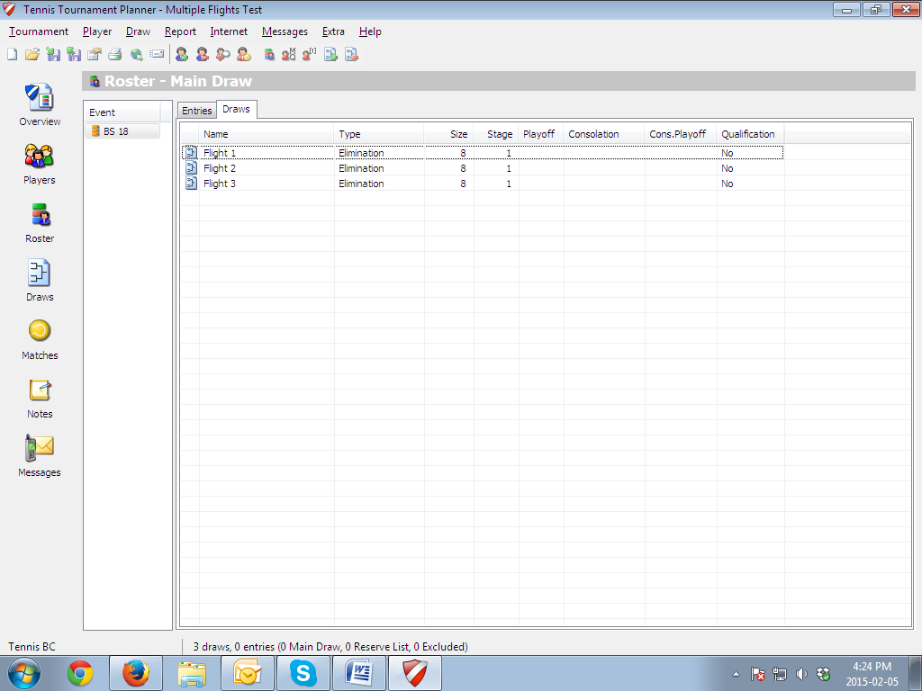

1. Double click on each draw and assign the correct Position to each one. For example the winner of Flight 1 would be Position 1. The winner of Flight 2 would be Position 9 ect.

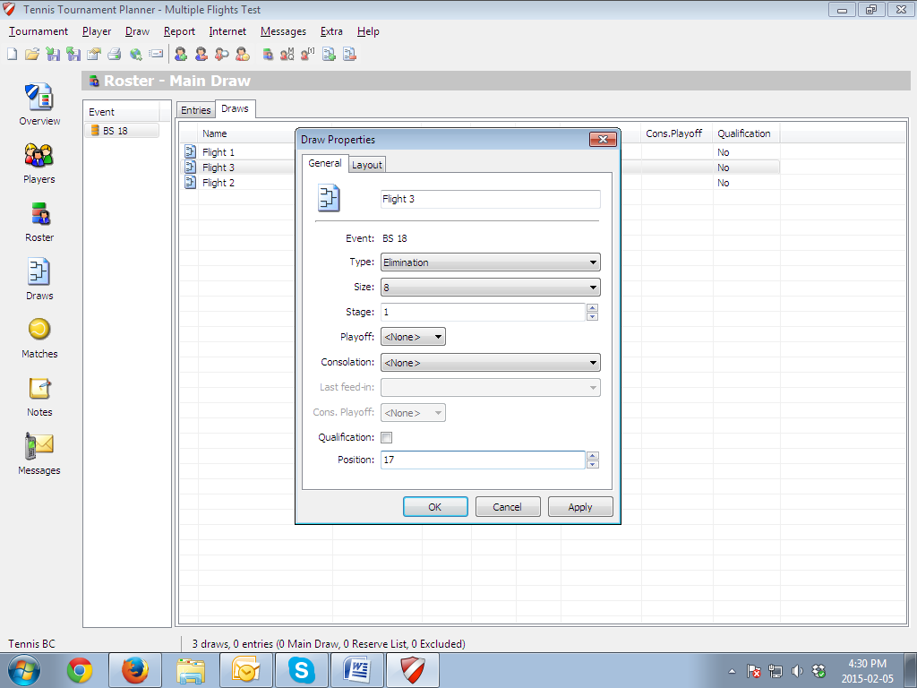

1. You can add the seeding of each player by clicking on Entries in the roster tab. Double click on a player and add their seed.

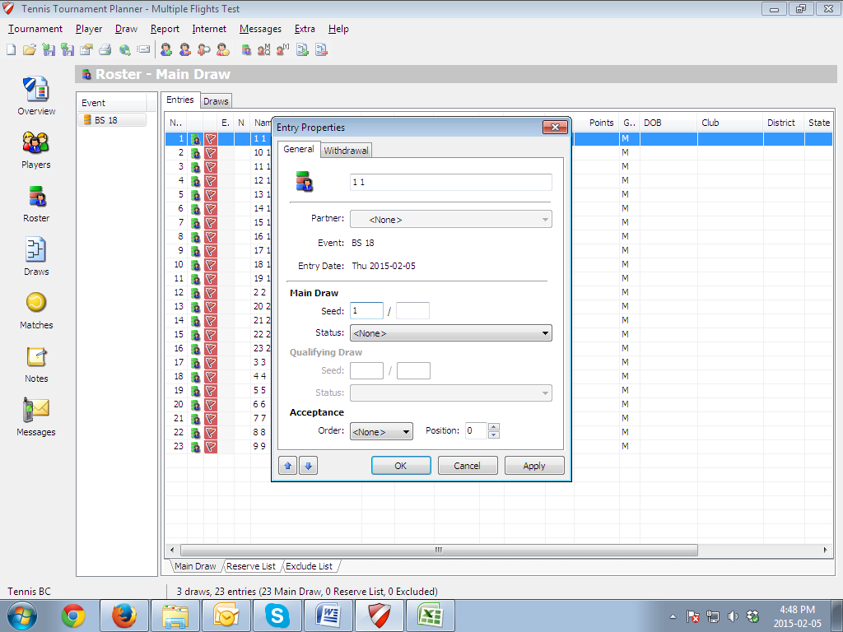

1. You can now enter your players in the draws by clicking on draws on the left toolbar and double clicking on any blank entry as seen below:

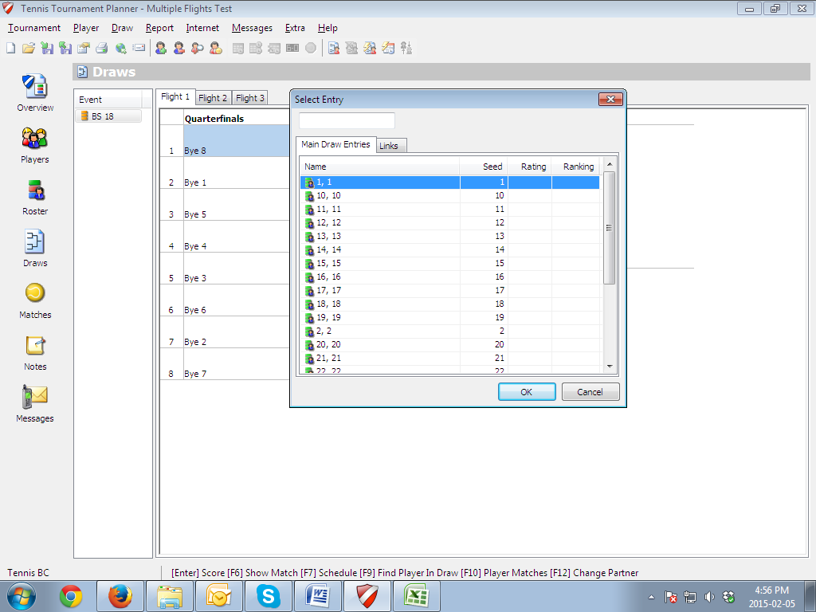

**Round Robin Qualification to Flights**

1. If your tournament sets the flights through a round robin qualification, you can add Round Robin draws to the tournament. Make sure that you adjust the elimination draws to Stage 2 and check the Qualifying box in the Round Robin Draws. You can do all this by double clicking on any of the draws under the Roster tab.

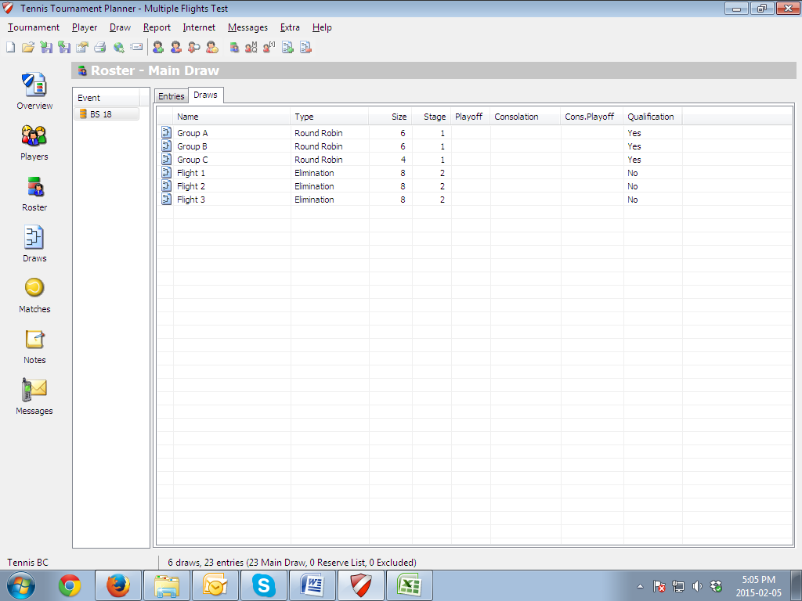

1. Click on the Draws tab on the left hand side of the screen. Click on any of the Flights and double click on a Bye position. Click on Links. Here you can decide where each person will go in the Flights based on their finishing position in the Round Robin.

